

Requirement & Design Specification

**Net Management System (NMS)**

**Version: 1.0**

– Hanoi, August 2022 –

# 

Contents

I. Overview 3

1. System Context 3

2. User Requirements 3

2.1 Actors 3

2.2 Diagrams- 4

2.3 Descriptions 4

3. System Functionalities 6

3.1 Screens Flow 6

3.2 Screen Authorization 6

3.3 Non-UI Functions 8

II. Functional Requirements 8

1. Feature Name1 8

1.1 SubFeature Name1.1 8

1.2 SubFeature Name1.2 8

2. User Authentication 9

2.1 User Register 9

2.2 User Login 9

2.3 Password Reset 9

2.4 User Profile 9

3. System Administration 9

3.1 Master Data 9

3.2 User Management 10

III. System Design 11

1. Database Design 11

1.1 Database Schema 11

1.2 Table Descriptions 11

# I. Overview

## 1. System Context

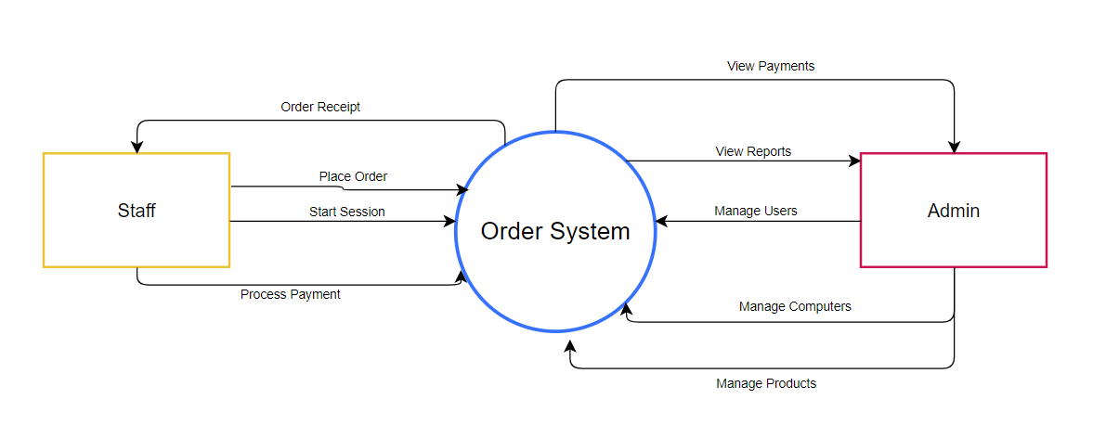

## 2. User Requirements

### 2.1 Actors

| **#** | **Actor** | **Description** |
| --- | --- | --- |
| 1 | Admin | The system administrator who has full control over the system, including user management, revenue reports, computer list, and system settings |
| 2 | Staff | A staff member responsible for starting sessions, processing payments, adding food/drink orders, and assisting customers at the front desk |

### 2.2 Diagrams-

#### 

### 2.3 Descriptions

| **ID** | **Use Case** | **Actor(s)** | **Use Case Description** |
| --- | --- | --- | --- |
| UC01 | Login | Staff, Admin | As a system user, I want to log in using my credentials so that I can access the system’s features. |
| UC02 | View Dashboard | Staff, Admin | As a logged-in user, I want to view a dashboard so that I can quickly navigate to key system functionalities. |
| UC03 | Manage Computers | Staff | As a staff member, I want to manage computer information so that I can keep the computer list up to date. |
| UC04 | Add Computer | Staff | As a staff member, I want to add a new computer to the system so that I can track available resources. |
| UC05 | Edit Computer Type | Staff | As a staff member, I want to change the type of a computer so that the system reflects its correct function. |
| UC06 | Start Session | Staff | As a staff member, I want to start a session for a customer so that they can begin using a computer. |
| UC07 | View Session Details | Staff | As a staff member, I want to view detailed session info so that I can track customer activity and charges. |
| UC08 | Select Product | Staff | As a staff member, I want to view and select products for the customer so that their order can be recorded. |
| UC09 | Add Product to Session | Staff | As a staff member, I want to add products to the customer's session so that they can be billed accordingly. |
| UC10 | End Session | Staff | As a staff member, I want to end a session and calculate costs so that I can provide a receipt to the customer. |
| UC11 | View Customer History | Staff | As a staff member, I want to view a customer’s history so that I can offer better service based on usage. |
| UC12 | View Revenue Report | Admin | As an admin, I want to view revenue reports so that I can analyze business performance. |
| UC13 | Manage Products | Admin | As an admin, I want to manage products so that the available items are accurate and up to date. |
| UC14 | Edit Product | Admin | As an admin, I want to edit product details so that I can correct or update information. |
| UC15 | Manage Accounts | Admin | As an admin, I want to manage user accounts so that I can assign roles and access. |
| UC16 | Edit Account | Admin | As an admin, I want to edit account information so that user data remains accurate and current. |

## 3. System Functionalities

### 3.1 Screens Flow

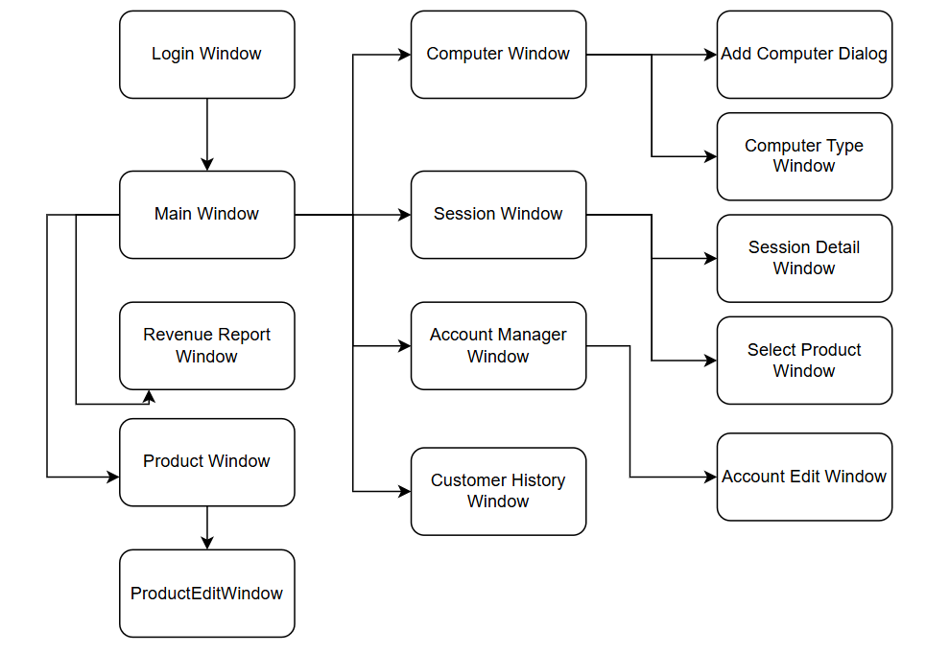

### 3.2 Screen Authorization

| **Screen** | **Role-Name1** | **Role-Name2** |
| --- | --- | --- |
| LoginWindow | X | X |
| MainWindow | X | X |
| <<Open Dashboard>> | X | X |
| AccountManagerWindow | X |  |
| <<View/Edit Accounts>> | X |  |
| AccountEditWindow | X |  |
| <<Edit Account Info>> | X |  |
| AddComputerDialog | X |  |
| <<Add New Computer>> | X |  |
| ComputerWindow | X | X |
| <<Manage Computers>> | X | X |
| ComputerTypeWindow | X |  |
| <<Edit Computer Types>> | X |  |
| CustomerHistoryWindow |  | X |
| <<View Customer History>> |  | X |
| ProductWindow | X | X |
| <<View Products>> | X | X |
| ProductEditWindow | X |  |
| <<Edit Products>> | X |  |
| RevenueReportWindow | X |  |
| <<View Revenue Report>> | X |  |
| SelectProductWindow | X | X |
| <<Select Product>> | X | X |
| SessionWindow | X | X |
| <<View Sessions>> | X | X |
| SessionDetailWindow | X | X |
| <<View Session Details>> | X | X |

### 

### 

### 

### 3.3 Non-UI Functions

| **#** | **Feature** | **System Function** | **Description** |
| --- | --- | --- | --- |
| 1 | Auto Logout | SessionTimeoutChecker | Automatically logs out users after a period of inactivity. |
| 2 | Daily Revenue Summary | DailyRevenueBatchJob | Automatically calculates and stores daily revenue statistics. |
| 3 | Trainer Booking Expiry Check | TrainerBookingStatusUpdater | Automatically updates trainer booking statuses if overdue and unpaid. |
| 4 | Email Notification | NotificationScheduler | Sends scheduled email notifications for class reminders, bookings, etc. |
| 5 | Backup Database | NightlyDatabaseBackupService | Automatically performs nightly backups of the database to storage server. |

# II. Functional Requirements

## 1. Feature Name1

### 1.1 SubFeature Name1.1

#### 1.1.1 Main window

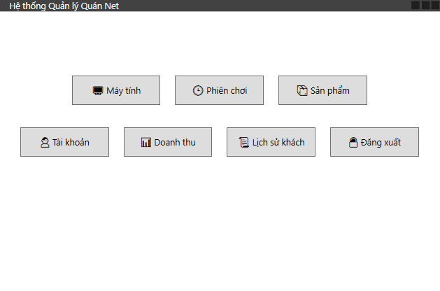

| **Field Name** | **Description** |
| --- | --- |
| Field Name1 | Field description: data type min/max length or value, initial data, etc. |
| Field Name2 | … |
| ***Field Group-Name1*** | |
| Field Name3 | … |
| Field Name4 | … |
| ***Field Group-Name2*** | |
| … | … |

#### 1.1.2 Screen/Function Name2

…

### 1.2 SubFeature Name1.2

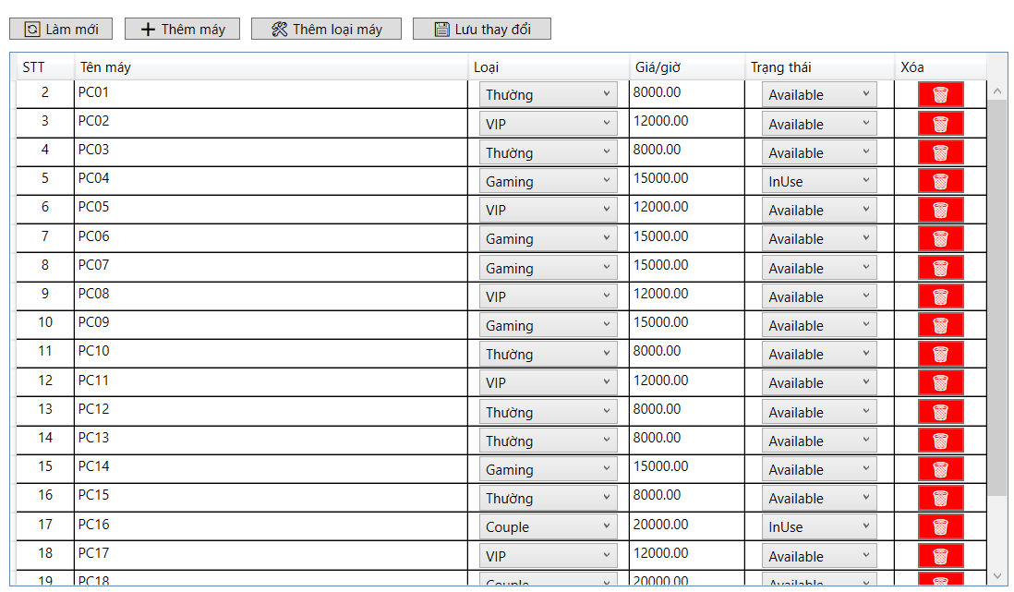

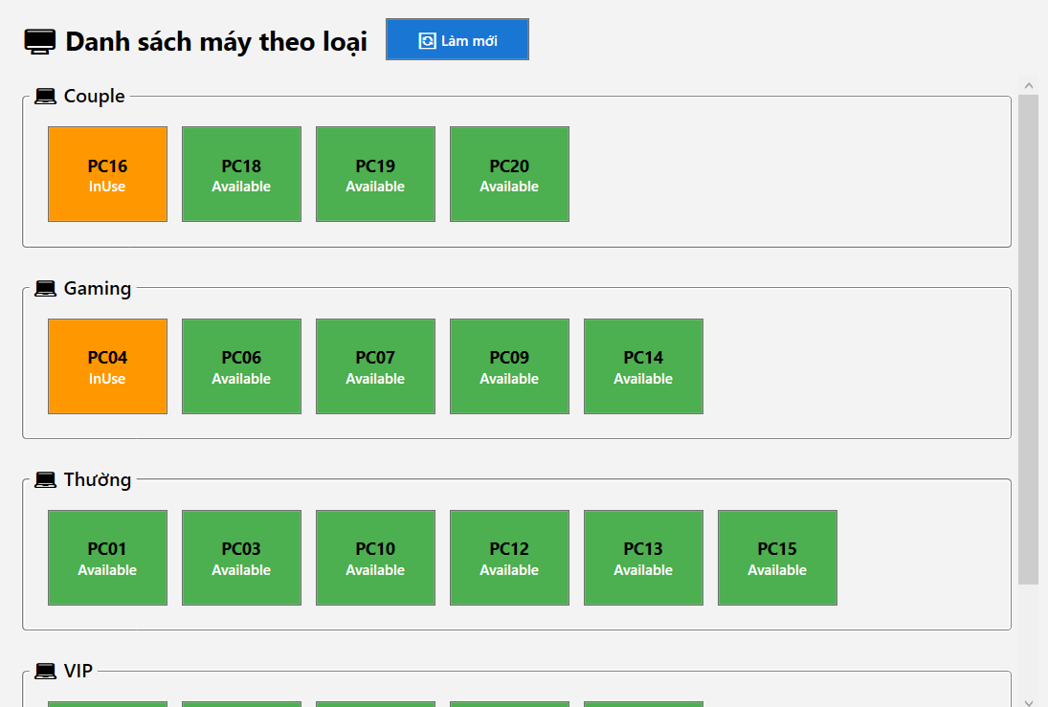

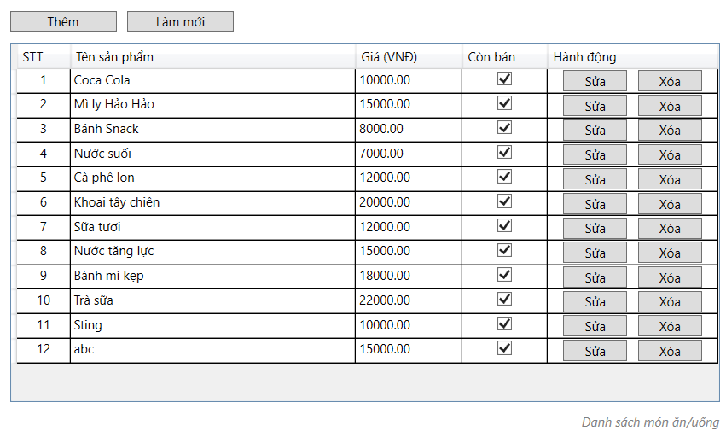

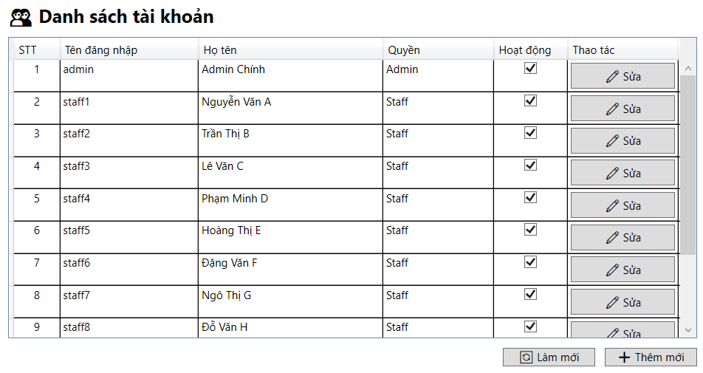

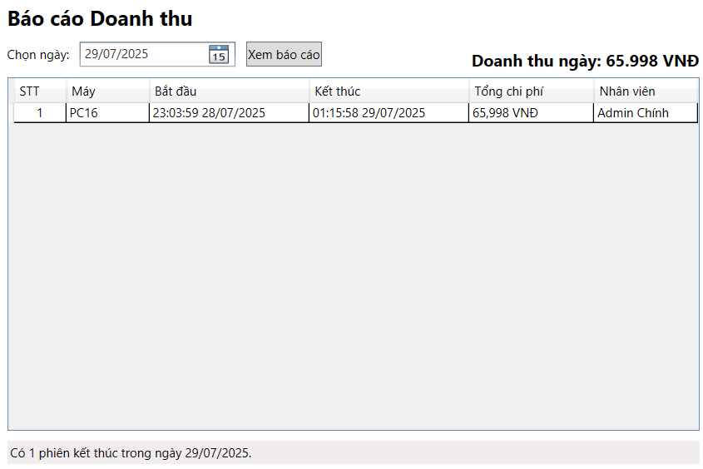

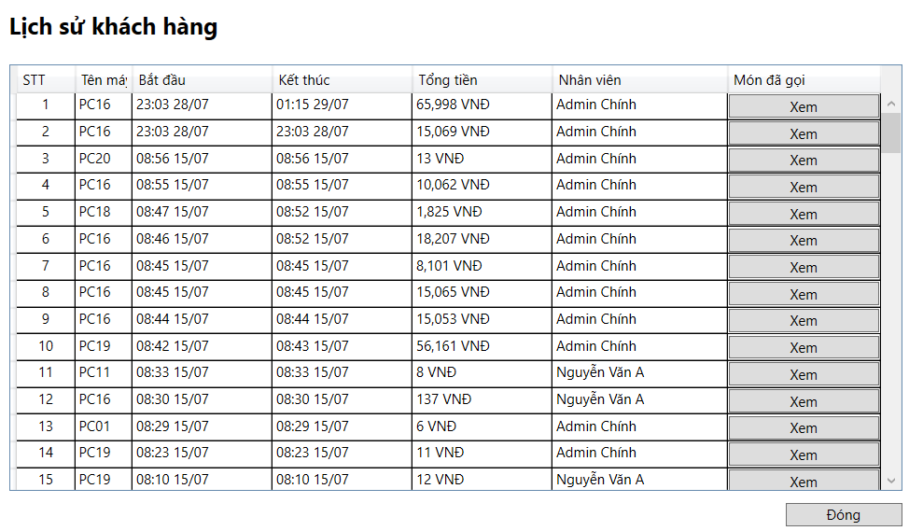

## 2. User Authentication

### 2.1 User Register

…

### 2.2 User Login

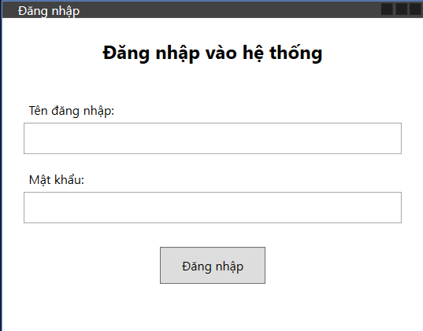

## 3. System Administration

### 3.1 Master Data

#### 3.1.1 Revenue Report Window





This screen allows the Administrator to:

* View Setting List: view list of current master data.
* Filter Setting List: filter master data by data types, statuses
* Search Settings: enter keyword(s) to search master data by their names or values
* Sort Setting List: sort mater data list (ascending, descending) by clicking column headers

On the screen, s/he can also

* Activate/Deactivate Setting: change status of a specific inactive/active master data
* Choose to go to the Setting Details screens for adding new or updating an existing master data by clicking the New Setting or Edit link.

**Field Description**

| **Field Name** | **Description** |
| --- | --- |
| (1) | Initial values: all the active setting names with null or blank type  Hover the mouse to show the field name: “Setting Type” |
| (2) | Initial values: All Statuses, Active, Inactive (default value “All Status”)  Hover the mouse to show the field name: “Setting Status” |
| (3) | The change-status action is Activate or Deactivate depending on the current status of the relevant setting (Inactive or Active, respectively). |

#### 3.1.2 Setting Details

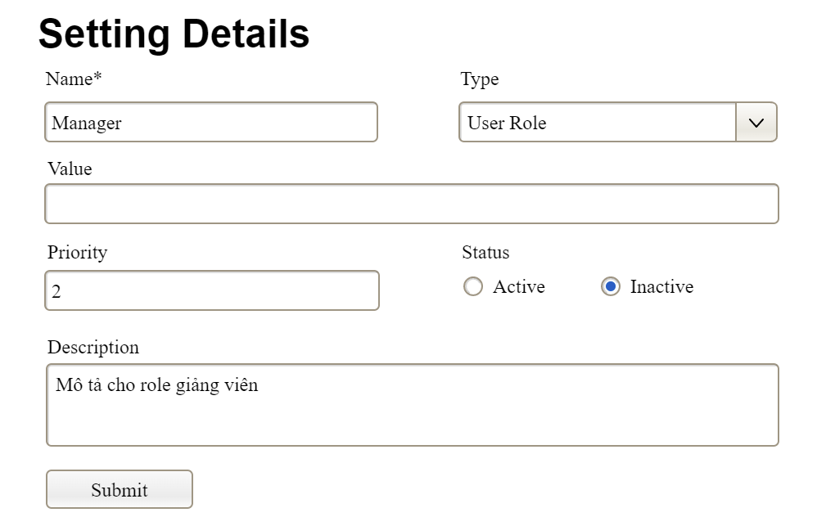

This screen allows the Administrator to:

* Add New Setting: add new master data.
* Update Setting Details: update details of a specific master data

**Field Description**

| **Field Name** | **Description** |
| --- | --- |
| Name | Data type: non-digit string, max length of 20 characters |
| Type | Initial data values: all active setting names (with null or blank type) |
| Value | Data type: any string, max length of 100 characters |
| Priority | Data type: a positive integer |
| Description | Data type: any string, max length of 200 characters |

### 3.2 User Management

#### 3.2.1 User List

…

#### 3.2.2 User Details

…

# III. System Design

## 1. Database Design

### 1.1 Database Schema

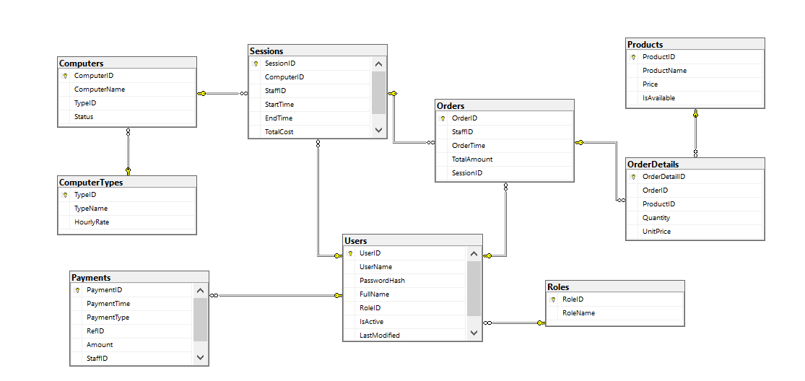

### 1.2 Table Descriptions

| **No** | **Table** | **Description** |
| --- | --- | --- |
| 1 | **Roles** | Stores different user roles such as admin or staff. Each role has a unique ID and name. |
| 2 | **Users** | Contains user login and profile information including username, password hash, full name, assigned role, and status. |
| 3 | **ComputerTypes** | Defines types of computers (e.g., standard, gaming) with associated hourly rates. |
| 4 | **Computers** | Represents individual computers in the system. Each computer is assigned a type and has a status (Available, InUse, Maintenance). |
| 5 | **Sessions** | Logs session information when a user starts and ends using a computer. It includes the computer used, staff handling the session, start/end time, and total cost. |
| 6 | **Products** | Stores information about products (e.g., food, drinks) available for sale, along with their prices and availability. |
| 7 | **Orders** | Records customer orders made during sessions, including the staff who processed the order, order time, and total amount. |
| 8 | **OrderDetails** | Stores detailed items of each order, including product ID, quantity, and unit price. |
| 9 | **Payments** | Records all payments made for sessions or orders. Each payment is linked to either a session or an order via RefID, and includes amount, time, and the staff who processed it. |